Student ID: BC080400090 : CS403: Fall 2016 : Assignment 01

Assignment
Suppose, we want to start an online shopping store where customers can buy any item(s) of his/her choice from the available items on the store using debit/credit card. The online shopping store should provide the following features to its customers.

- Search item from the store
- Manage shopping list
- Place order using his/her debit/credit card

After placement of the order, system should verify the debit/credit card information and deliver the item(s) to customer after verification.

Now, you are required to identify different processes, sub-processes (if any) and data store(s) from the given scenario and draw context level data flow diagram and Level 1 data flow diagram for this store.

Index of this document
Page 2 : Context diagram
Page 3 : Level 0 Diagram
Page 3 : Source files

Context Diagram
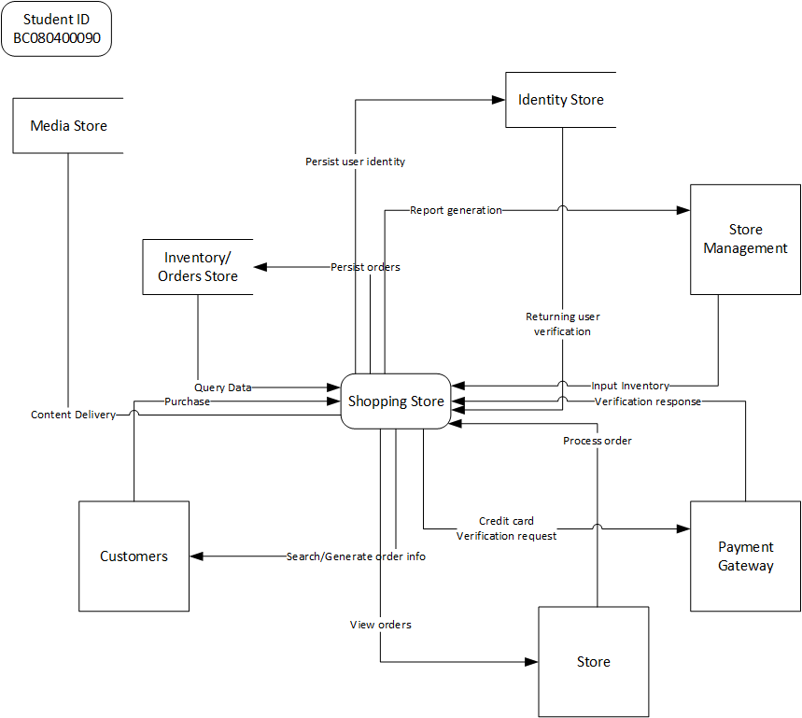

Level0 diagram (Check next page in this word file)
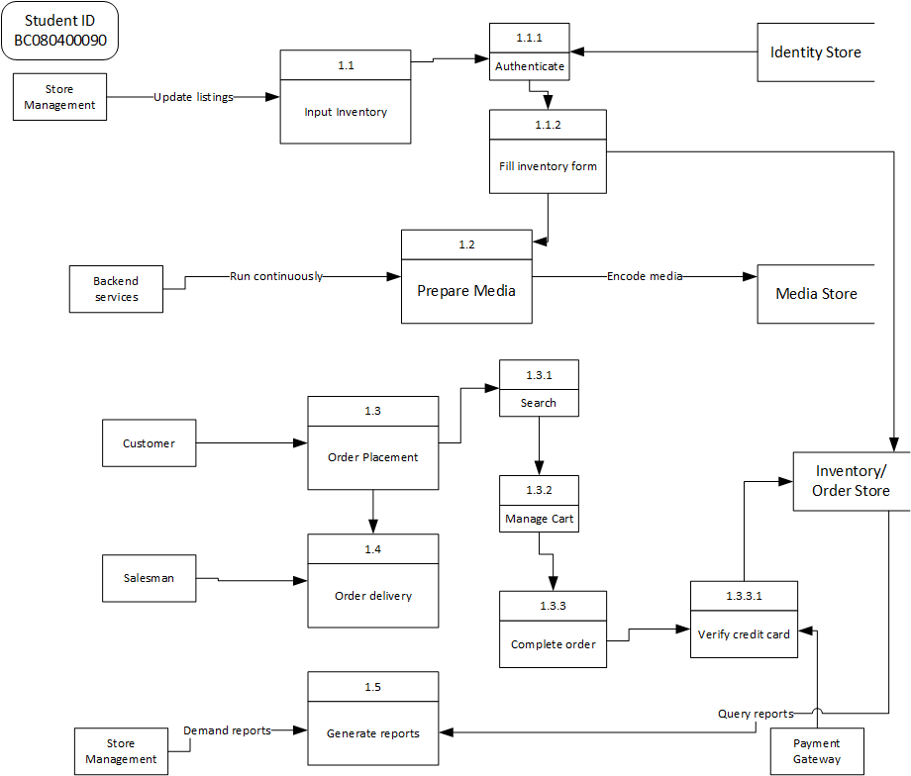

I have places source VISIO and exported PNG Files for your view here on a public url
https://www.dropbox.com/s/yydclrpdpjnt9rt/Assignment_01_BC080400090.zip?dl=1
Short url: https://goo.gl/XXmHQk

